# 

# Table of Content

# 

**Table of Content 5**

**Introduction 7**

**Activity 2 : Case Study Organisation 8**

Task 1 : Design New Organisation Structure 8

Task 2 : List Current System Used 9

Task 3 : Describe System Function 9

**Activity 3 : System Planning - Preliminary Investigation 10**

Task 1 : Describe Sources of Request 10

Task 2 : Describe Services / Improvements Requested 11

**Activity 4 : System Planning - Feasibility Study 12**

Task 1 : Construct a Cost Summary Table **12**

Task 2 : Construct a Benefits Summary Table 13

**Activity 5 : System Analysis - Fact Gathering 14**

Task 1 : Design Interview Questions 14

Task 2 : Design Questionnaires 15

**Activity 6 : System Analysis - Fact Recording 17**

Task 1 : Draw Context Diagram 17

**Activity 7 : System Analysis - Fact Recording 18**

Task 1 : Draw Diagram 0 DFD 18

**Activity 8 : System Analysis - Fact Recording 18**

Task 1 : Draw ERD 19

Task 2 : Resolve Many-to-Many Relationship 19

**Activity 9 : System Design - Functional Design 20**

Task 1 : Draw Functional Structure Chart 20

Task 2 : Describe Sub-system Functions 21

**Activity 10 : System Design - Input 21**

Task 1 : Design Data Input Screen 22

Task 2 : Identify Validation Checks 23

Task 3 : Describe User-Friendliness Features 24

**Activity 11 : System Design - Data Definition 24**

Task 1 : Make a Copy of ERD (Resolved) 25

Task 2 : Create Attributes 25

**Activity 12: System Design - Database 26**

Task 1 : Select Entities and Draw an ERD 26

Task 2 : Design Code (Primary Key) 26

Task 3 : Populate Data Records 26

**Activity 13: System Design - Outputs / Reports 28**

Task 1 : Design a Summary Report 28

Task 2 : Design an Exception Report 28

**Appendixes : 29**

**References : 32**

# 

# Introduction

# 

**SDLC Phases Overview:**

Our project covers some of the traditional SDLC phases, namely System Request, System Planning, System Analysis and System Design. Each phase is carried out to ensure a systematic and well-structured development process, leading to the successful operation of the Sales System. During the System Planning Phase, we identified the sources of request and type of services/improvements needed. Furthermore, we identified the various costs and benefits gained by implementing the new system to prevent profit loss. Next, during the System Analysis Phase, we decide to carry out interviews and give out questionnaires to get users' opinions or problems faced during the old system. Moreover, we had to draw a context diagram, Diagram 0 DFD and ERD to determine the data flow in the system and the relationship between the entities in the system. Lastly, during System Design Phase, we constructed a Functional Structure Chart to determine the sub-system of the Sales System and designed a user input screen. We carried out the data validation check to ensure that the system is free from data error. In addition, we created attributes for all the entities in ERD to ease data recording. Last but not least, we designed a Summary Report and Exception Report that is important for supporting the company’s future goals and business growth.

**Purpose:**

The primary purpose of this assignment is to perform a comprehensive Systems Analysis and Design for the Sales System. This involves understanding the organisation's current state, identifying areas for improvement, and proposing a tailored system to streamline sales processes, enhance efficiency, and ultimately contribute to the organisation's profitability.

**Methodology Used:**

Our methodology integrates industry best practices and standards, acknowledging Nestlé's commitment to quality and innovation.

**System Proposed:**

The proposed Sales System is designed to revise the way our organisation conducts sales-related activities. From managing quotations to processing orders, the system aims to optimise workflows, reduce processing times, and provide in-time information and reports to decision-makers.

**Industry or Organization Reference:**

We had used the Nestlé organisation for reference when we did our project. Nestlé, a multinational company with a rich history, operates in the food and beverage sector, offering a diverse range of products. The organisation follows a dynamic business model, encompassing partnerships with suppliers, distributors, and retailers globally. Nestlé's commitment to sustainable practices and a consumer-centric approach reflects its position as a leader in the industry.

# 

# Activity 2 : Case Study Organisation

## Task 1 : Design New Organisation Structure



## Task 2 : List Current System Used

## Task 3 : Describe System Function

1. Customer Relationship Management (CRM) system
2. Supply Chain Management (SCM) System
3. Enterprise Resource Planning (ERP) Systems
4. **Sales System**

Functions :

* **Receive RFQ -** The Request for Quotation (RFQ) function involves the initiation and generation of a document that outlines a buyer's specific requirements for products or services, such as product specifications, quantities, delivery schedules, and any other relevant terms and conditions.
* **Features -** Our company will provide an online form to our customers to receive their details such as company name, desired product and quantity of product. We will also inform our stakeholders about the status of their RFQ submissions via email.
* **Create and send quotations -** The first step in the sales process which provides customers with detailed information about the cost and terms associated with a product or service.
* **Features -** Our company will create our quotation which includes details such as product name, negotiable price range and other customer requirements. We will provide a way for customers to view and download their quotations.
* **Receive and approve orders from customers -** The process of acknowledging, reviewing, and approving customer orders.
* **Features -** Our company checks orders to meet criteria and matches them with available stock, such as integrating with inventory systems to ensure orders. We will also access customers’ credit status based on their payment history and business duration.
* **Prepare Delivery Schedule (for Warehouse) -**

**Function**: The system helps in planning and scheduling the delivery of approved orders, providing information to the warehouse for fulfilment.

* **Features -** Our company partners with reliable logistics for safe and timely deliveries. We will update customers via email, tracking orders regularly for status updates. Furthermore, dynamic scheduling is based on inventory availability and delivery constraints. Moreover, route optimization for efficient deliveries. Lastly, real-time updates on delivery progress and potential delays.

# Activity 3 : System Planning - Preliminary Investigation

## Task 1 : Describe Sources of Request

1. **From Top Management**

The top management is requesting a new system which could support **new organisational objectives**. The organisation is facing problems such as gaining low profit caused by high costs, which will not support our company's future growth. For example, infrastructure costs, such as upgrading or investing in the necessary hardware, servers, and networking infrastructure to support the sales system. Moreover, the top management needs **better quality of reports** in a **shorter time** for better decision making. The current reports may be not accurate and take a long time to generate. The top management is planning to expand the organisation's market share or enter new markets, the sales system might need enhancements or new features to support these initiatives.

1. **From Users**

The users’ needs for **new features** to support new roles or to **solve existing system problems.** For example, when the sales managers are creating quotations, they find out that the prices of products are very low until they do not make any profits. Furthermore, the **system performance** is **very poor**. For instance, the sales managers find out that generating quotations or reports takes a very long time which will affect customer satisfaction and company decisions. Moreover, the users are encountering **challenges** related to data accuracy or consistency. For example, product prices in the generated quotations are not the same as the original prices. Lastly, they request a new system with **better data management capabilities** to ensure the **reliability of information**.

1. **From IS Department**

The IS department's own **recommendations** for projects. For example, IS personnel discovered poor performance of the existing system. As our organisation has approximately 300,000 employees, when the number of users increases, the system will face significant slowdowns and potential shutdowns. The time taken to generate quotations will be longer. Furthermore, the IS personnel **found lots of errors and bugs** exist in the system. For instance, the prices of products provided in the quotations generated by the system are different from the original prices. Moreover, the IS personnel requested to **improve the security** of the current system. For example, the current sales system may have a certain probability of exposing sensitive customer and pricing information to unauthorised access. This could lead to a significant risk of data breaches. Nevertheless, the **weak access controls** in the existing system might **allow unauthorised users**, both internal and external, to gain access to confidential sales data, compromising the integrity and confidentiality of the information.

## Task 2 : Describe Services / Improvements Requested

1. **Improve performance**

The system allows **a large number of users** to use the system at one time **without** facing any significant **slowdown**. For example, system optimization. In addition, the system can **conduct a thorough performance analysis** to identify bottlenecks and inefficiencies within the system. For example, the system can optimise database queries, improve code efficiency and address any resource-intensive processes that lead to slow performance. Furthermore, **optimising the system** ensures that the **quotation generation** process is **faster**. This results in a more responsive system when sales representatives request and generate quotations, leading to quicker turnaround times. This directly translates to faster report generation times, allowing for quicker access to essential sales data. Moreover, **upgrading the hardware and infrastructure**. For instance, increasing server capacity, upgrading network components, or moving to more powerful hosting environments. This could enhance the system's overall capacity, reducing latency during quotation generation. Eventually, the system can handle increased load and deliver quotations promptly.

1. **Create Effective Controls**

The organisation should **adopt role-based access control** and **enforce the principle of least privilege**. This involves restricting user access to only the essential functions necessary for their roles, minimising the risk of unauthorised data manipulation or breaches. For example, only sales representatives, sales managers and top management can access customers' details and product prices. Furthermore, **enforce strong authentication mechanisms**, such as multi-factor authentication, to enhance user verification. This adds an extra layer of security and ensures that only authorised users can access the sales system. For instance, using both fingerprint reader and passphrase at the same time to access the system. In addition, use **encryption for data** both in transit and at rest. This ensures that sensitive information, including customer data and pricing details, is protected from unauthorised access or interception. For example, only the sales department and top management are given encryption keys to access a private file. At the same time, **regularly back up critical sales data** to prevent data loss in case of system failures or security incidents. **Implement a data backup and recovery strategy** to ensure business continuity. For example, when a customer requests for a refund, the company can refer back to the previous order details that are saved and backed up. Moreover, keep all software components of the sales system up-to-date by applying **security patches and updates** promptly. This helps in addressing known vulnerabilities and reducing the risk of exploitation.

# Activity 4 : System Planning - Feasibility Study

## Task 1 : Construct a Cost Summary Table

| Cost Component | Quantity | Unit Cost (RM) | Total Cost (RM) | Explanation |
| --- | --- | --- | --- | --- |
| Hardware Costs |  |  |  |  |
| Servers | 6 | 7889.00 | 47334.00 | For handling system load |
| Clients Computer | 40 | 1999.00 | 79960.00 | Workstations for system users |
| Network Infrastructure | 2 | 3213.00 | 6426.00 | Switches, Routers, Cables, etc |
| Software Costs |  |  |  |  |
| Operating System | 40 | 399.00 | 15960.00 | OS licences for client computers |
| Database Management System | 2 | 4621.60 | 9243.20 | Licence for the database management system |
| Development Tools | 1 | 15386.00 | 15386.00 | Tools required for software development |
| Development Costs |  |  |  |  |
| System Analyst Salary | 10 | 5849.00 | 701880.00 | Salary for the system analyst during requirements phase/month |
| Software Developer Salary | 10 | 4000.00 | 480000.00 | Salary for developers during system development/month |
| Implementation Costs |  |  |  |  |
| Installation | - | - | - | Cost associated with the installation of the system |
| Data Migration | - | - | - | Cost for migrating data from old to new system |
| Training | 40 | 5000 | 200000 | Training cost for system users |
| System Changeover | - | - | - | Cost associated with transitioning to the new system |
| Total Estimated Cost | | | 1556189.20 |  |

## 

## Task 2 : Construct a Benefits Summary Table

|  |  |  |  |
| --- | --- | --- | --- |
|  | Profits (RM) | Calculation | Description |
| Tangible Benefits |  |  |  |
| Increase Sales | 50M | 150M (New system) - 100M (Old system) | Produce better quality reports for better decision making such as changing the price range, and shorten the time taken for generating the quotation thus improving customer satisfaction and sales. |
| Increase Productivity | Number of quotations increased by 3 | 5 quotations per person per day (New system) - 2 quotations per person per day (Old system) | Increase output per staff, for example, a staff can produce multiple quotations per day. |
| Intangible Benefits |  |  |  |
| Greater Reliability and Security | - | - | Stricter access control to prevent unauthorised access. |
| More timely and up-to-date information | - | - | Reports are produced more accurately and quicker, thus decisions can be made more easily. |

# Activity 5 : System Analysis - Fact Gathering

## Task 1 : Design Interview Questions

**Interviewee :**

Staff of Sales Department

**System Function Problem :**

Slow quotations generation caused by slow system performance.

**Questions :**

1. What is your job role in our organisation?
2. Can you describe your day-to-day workflow?
3. How do you think the current delays in the quotation generation affect the relationships with clients or other departments within the organisation?
4. When do you notice that quotation generation takes a long time?
5. From your perspective, what improvements or additional features of the system can enhance the speed of the quotation generation process?
6. In your opinion, how does the prolonged quotation generation time influence the competitiveness of our organisation in the market?

## Task 2 : Design Questionnaires

## 

## 

**Questionnaire on Quotation Generation Issues**

**Introduction**

Hello, we are from the IS department. We would like to gather your opinion regarding the slow quotation generation problem caused by slow system performance. We would really appreciate it if you could complete the following questionnaires and return it by January 2 to the IS Department.

**Your observations**

1. How long does it take the system to generate one quotation?

* 10-20 minutes
* 30-40 minutes
* 50-60 minutes
* Other : ____________

1. How many quotations can be generated and sent to clients by you in one day?

* 1-2
* 3-4
* 5-6
* 7-8
* 9-10
* Other : ____________

1. What is your job role in our organisation?

__________________________________________________________________________________________________________________________________________________________________________________________________________________________________________

______________________________________________________________________________

______________________________________________________________________________

1. Can you describe your day-to-day workflow?

______________________________________________________________________________

______________________________________________________________________________

__________________________________________________________________________________________________________________________________________________________________________________________________________________________________________

1. When do you notice that quotation generation takes a long time?

______________________________________________________________________________

______________________________________________________________________________

**__________________________________________________________________________________________________________________________________________________________________________________________________________________________________________**

1. Describe a specific scenario where delays in generating quotations had a direct impact on your workflow or the efficiency of the sales processes.

**____________________________________________________________________________________________________________________________________________________________**____________________________________________________________________________________________________________________________________________________________**______________________________________________________________________________**

1. How have the delays in the quotation system influenced the stress levels and morale of your team?

**______________________________________________________________________________**____________________________________________________________________________________________________________________________________________________________**____________________________________________________________________________________________________________________________________________________________**

**Your suggestions**

1. What improvements or additional features by the system can enhance the speed of the quotation generation process?

____________________________________________________________________________________________________________________________________________________________

______________________________________________________________________________

______________________________________________________________________________

______________________________________________________________________________

# Activity 6 : System Analysis - Fact Recording

## Task 1 : Draw Context Diagram

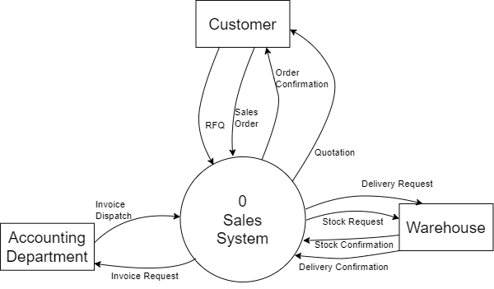

# Activity 7 : System Analysis - Fact Recording

## Task 1 : Draw Diagram 0 DFD

## 

# Activity 8 : System Analysis - Fact Recording

## Task 1 : Draw ERD

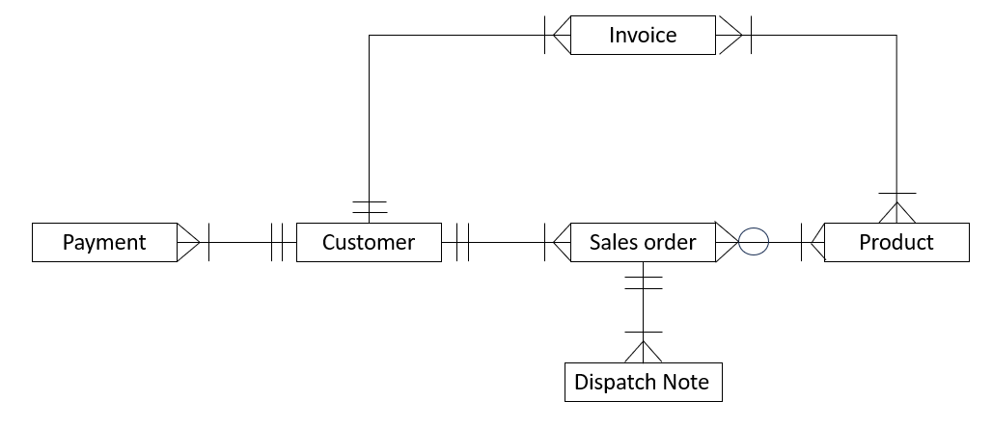

## Task 2 : Resolve Many-to-Many Relationship

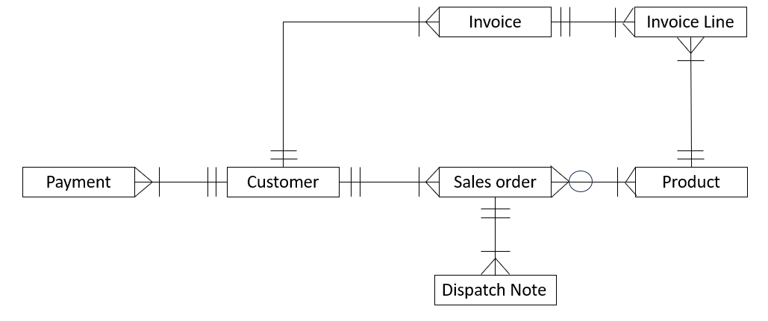

# Activity 9 : System Design - Functional Design

## Task 1 : Draw Functional Structure Chart

## 

## 

## Task 2 : Describe Sub-system Functions

## 

**Manage Quotation**

1. Receive Request for Quotation (RFQ) from the customers
2. Create Quotation - Create quotations by giving prices of products based on the ordered product quantity
3. Send quotation - Send quotations to the customers before a certain deadline.
4. Generate Quotation Report - To determine the overall cost, which is calculated based on the quantity and unit prices.

**Manage Order**

1. Receive orders from the customers
2. Approve orders - Approve customers’ orders after checking the stock balance from the warehouse
3. Process orders - Send order details to the warehouse for shipment.
4. Cancel orders - Approve order cancellations from customers.

# Activity 10 : System Design - Input

## Task 1 : Design Data Input Screen

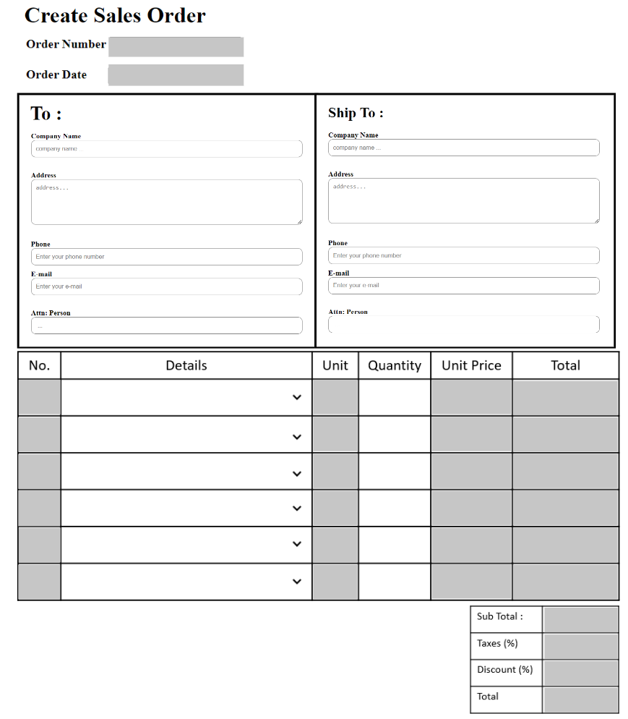

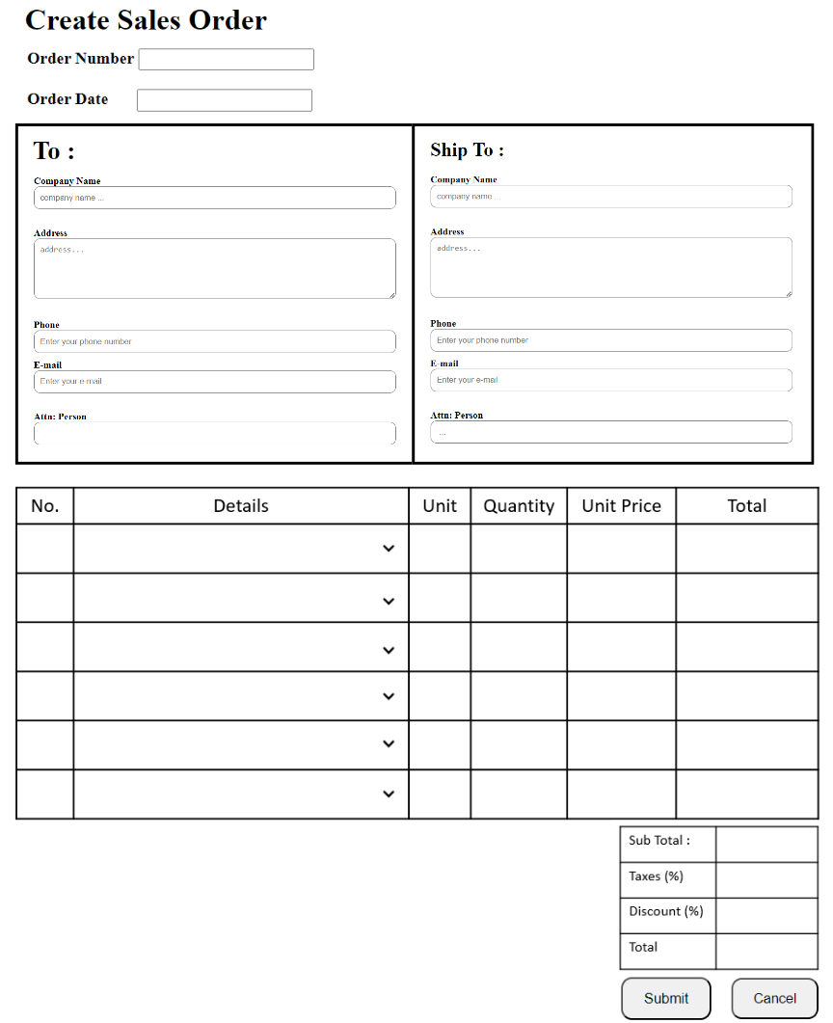

## Task 2 : Identify Validation Checks

# 

|  |  |  |  |  |
| --- | --- | --- | --- | --- |
| **No.** | **Field** | **Input Method** | **Validation Check** | **Explanation** |
| **1** | **Order Number** | **Auto-generated** | **-** | **The order number is auto-generated by the system** |
| **2** | **Order Date** | **Auto-generated** | **-** | **The date that the customer order** |
| **3** | **Company Name** | **Manual keying** | **Presence Check** | **Entry of data is via keyboard by hand** |
| **4** | **Address** | **Manual keying** | **Format Check, Presence Check** | **Entry of data is via keyboard by hand** |
| **5** | **Phone** | **Manual keying** | **Size Check, Data Type Check** | **Entry of data is via keyboard by hand and must not contain alphabetic values** |
| **6** | **E-mail** | **Manual keying** | **Format Check** | **Entry of data is via keyboard by hand and must contain @ symbol** |
| **7** | **Attn: person** | **Manual keying** | **Null Value Check, Format Check** | **Entry of data is via keyboard by hand and must not contain numeric values** |
| **8** | **No.** | **Auto-generated** | **-** | **The number is auto-generated by the system** |
| **9** | **Details** | **Pull-down list** | **-** | **Entry of data is by selecting the options from the drop-down list that shows the products list** |
| **10** | **Unit** | **Imported data from another document** | **-** | **Data entry is by importing data from product table** |
| **11** | **Quantity** | **Manual keying** | **Limit Check** | **Entry of data is via keyboard by hand and must be greater than 0** |
| **12** | **Unit price** | **Imported data from another document** | **-** | **Data entry is by importing data from product table** |
| **13** | **Total** | **Auto-generated** | **-** | **The total is auto-generated by the system** |
| **14** | **Sub Total** | **Auto-generated** | **-** | **The subtotal is auto-generated by the system** |
| **15** | **Taxes(%)** | **Auto-generated** | **-** | **The taxes is auto-generated by the system** |
| **16** | **Discount(%)** | **Auto-generated** | **-** | **The discount is auto-generated by the system** |
| **17** | **Total** | **Auto-generated** | **-** | **The total is auto-generated by the system** |

# 

## Task 3 : Describe User-Friendliness Features

1. **Pull-down List at ‘Details’ field**

This is a list of options in a compact format. The pull-down list allows users to click or tap on it, which will cause a menu to "drop-down" and display a list of selectable items. In the data input screen, the details field allows the customers to click on it and it will show a list of our products that could be selected by the customers. The pull-down list helps conserve our data input screen space and brings customers convenience.

1. **Default Values**

The default values are used when the value of the field can be predicted with some certainty. It ensures the data always has a certain value if it could be predicted by the system. In the data input screen, the order number and the order date are two of the default values in the system as the system could output the order number and the order date is the date that the customers made their order.

# Activity 11 : System Design - Data Definition

## Task 1 : Make a Copy of ERD (Resolved)

# 

# 

## Task 2 : Create Attributes

## 

**CUSTOMER** (CustNo, CustName, Address, ContactNo)

**SALES ORDER** (OrderNo, OrderDate, Quantity, TotalPrice, ProdID*, CustNo*)

**PRODUCT** (ProdID, Description, ProdPrice, Balance)

**INVOICE** (InvoiceNo, Date, CustNo*)

**INVOICE LINE** (ProdID*, InvoiceNo*)

**PAYMENT**(PayID, Description, PayDate, CustNo*)

# Activity 12: System Design - Database

## Task 1 : Select Entities and Draw an ERD

## 

## 

## 

## Task 2 : Design Code (Primary Key)

**PayID** : VISA00001

Block sequence code is used. VISA is the type of payment. Other examples of type of payment are CASH, MAST (master), CHEQ (cheque). 00001 is the sequence of payment. The sequence of payment is increased by auto increment by the system. Maximum number of sequence of payment is 99999.

**CustNo :** CKL00001

Block sequence code is used. C stands for customer, KL stands for the regions, 0001 stands for the customer sequence. Other examples of regions are SL (Selangor) , PN (Penang) , JB (Johor). The customer sequence is increased by auto increment by the system. Maximum number of sequences of customers is 99999.

## 

## Task 3 : Populate Data Records

**PAYMENT**

|  |  |  |  |
| --- | --- | --- | --- |
| **PayID** | **Description** | **PayDate** | **CustNo** |
| VISA00001 | Visa | 23/02/2022 | CKL00001 |
| CHEQ22224 | Cheque | 13/04/2022 | CSL23991 |
| MAST55556 | Master | 11/11/2022 | CKL78302 |
| CASH34568 | Cash | 12/12/2022 | CKL34823 |
| CHEQ89621 | Cheque | 01/01/2023 | CKL85721 |

**CUSTOMER**

|  |  |  |  |
| --- | --- | --- | --- |
| **CustNo** | **CustName** | **Address** | **ContactNo** |
| CSL23991 | LiveTea Sdn Bhd. | G63A, Taman, Jalan Prima SG 3/1, Prima Seri Gombak, 68100 Batu Caves, Selangor | 0123456789 |
| CKL00001 | TimeChat Sdn Bhd. | G-9, Sentul Village Service Apartment, 1, Jln Sentul Pasar, 51100 Kuala Lumpur, Federal Territory of Kuala Lumpur | 0140070704 |
| CKL34823 | DonaldMac Sdn Bhd. | Lot GF32 & FF31, Waterfront Parkcity, Persiaran Residen, Desa Parkcity, 52200 Wilayah Persekutuan, Wilayah Persekutuan Kuala Lumpur | 0146589872 |
| CKL78302 | FKC Sdn Bhd. | Lot 3644 HS (D) 70344 &, Lot PT 8081 HS (D) 107241, Taman Melati, Mukim, 53100 Wilayah Persekutuan, Federal Territory of Kuala Lumpur | 0129876543 |
| CKL85721 | COFFEE SUZ Sdn. Bhd. | G-30, Eco Sky, 972, Batu 6 1/2, Jalan Ipoh, 68100 Kuala Lumpur. | 0135566443 |

## 

## 

# Activity 13: System Design - Outputs / Reports

## Task 1 : Design a Summary Report

## Task 2 : Design an Exception Report

## 

|  |  |  |  |  |  |
| --- | --- | --- | --- | --- | --- |
| No. | Type of Report | Report Title | Report Content | Who Use | Purpose / Decision |
| 1. | Summary report | Total sales for Megee for 12 months in Year 2023 | This reports the total sales, in quantity for ‘Megee’ for each month from January 2023 to December 2023. | Sales Manager | To determine the sales of that particular product and whether to produce more and having promotion and advertisement for that product. |
| 2. | Exception report | Top 5 Lowest Selling Product for 2023 | This reports the total sales of a particular product in terms of quantity for each of the months from January 2023 to December 2023. | Sales Manager | To determine the lowest selling products and make decisions such as eliminate or stop manufacturing that particular product to reduce profit loss. |

## 

# 

# Appendixes :

|  |  |
| --- | --- |
|  | **DELL POWEREDGE R240 / R250 RACK SERVER 1 SOCKET SERVER (1 CPU CONFIGURATION )**  RM 7889 |
|  | **Lenovo IdeaPad 3 15 Gen 8 (AMD)**  RM 1999 |
|  | **Tp-link Tl-sg105e 5 Ports Hub Switch Black**  RM 122.11 |
|  | |
|  | |
|  | |
|  | |

# 

# References :

* *Software Developer Salary in Malaysia (2022)*. (n.d.). JobStreet. <https://www.jobstreet.com.my/career-advice/role/software-developer/salary>
* *Systems Analyst salary in Malaysia*. (n.d.). Malaysia.indeed.com. <https://malaysia.indeed.com/career/systems-analyst/salaries>
* (2023). Lazada.com.my. <https://www.lazada.com.my/products/dell-poweredge-r240-r250-rack-server-1-socket-server-1-cpu-configuration-i1453298723-s13719758025.html?from_gmc=1>
* Nestle Malaysia. (2018). *Home*. Http://Www.nestle.com.my.

<https://www.nestle.com.my/>